**CHAPTER ONE**

**INTRODUCTION**

This chapter will describe the context in which this investigation was launched, the description of difficulties that led to this study, and the Aim and Objectives of the study as a prologue to subsequent aspects of this study. Others include the significance of the research, the scope of the work, study limitations, and definitions of technical terminologies.

**1.1** **Background of the Study**

Food and grocery shopping has undergone a revolution in every retail sector, with noticeable changes in customer purchasing behavior driven by high-income growth, changing lifestyles, and cost-effective and efficient online and mobile technology. Consumers' need for ease has grown as they devote less time to shopping and more to other activities, and their attention has frequently been diverted to virtual shopping as an alternative medium. Thus, the rapid expansion of the internet is altering the way people browse for and purchase items and services, and it has quickly become a worldwide phenomenon. As a result, one of the primary motivators behind customer preferences for online purchasing has been convenience. Although still in its early stages, online grocery is gaining pace and becoming increasingly incorporated into the everyday lives of customers in various areas. Despite the development and significance of online grocery shopping, little is known about how individuals buy goods online. Khan et al. (2020)

Grocery shopping in the 21st century is changing drastically, and one major element of this change is online grocery shopping (Peregrin, 2018). Given this prior work, when juxtaposed with in-store shopping, online grocery shopping has the potential to dramatically limit the impact of both the cognitive barriers to healthy food access as well as community access barriers related to healthy food purchase within the supermarket food environment: consumers can shop online at any time and online grocery shopping allows low-income food desert dwellers and customers with limited mobility to order groceries online and have them delivered (Appelhans, 2019).

Internet-based company is quickly becoming a recognized and used business strategy. More entrepreneurs are incorporating web-based commercial utilities and online exchange structures into their websites. So, it's not difficult to predict that within a couple of decades, the web will be the standard for purchasing any kind of product or administration. (Shuvo, 2018)

No firm can afford to ignore the functionality and new methods of conducting business that e-commerce provides. This application made advantage of business-to-consumer marketing (B2C). Online e-Commerce websites such as eBay provide a valuable platform for users to purchase and sell things. As a result, I decided to create a beneficial online grocery e-commerce platform that can be used by anyone and location bound free.

**1.2 Statement of the Problem**

The factors that influence the course of development of this work is the problem that customer encounter when they want to purchase groceries, customer have to practice in-store shopping, and some even go around with a lot of cash to purchase groceries which is very dangerous, all this problem motivate me to embark on this project work to eradicate the above problems mentioned. Thus, it is necessary to introduce an information system that would be used for the recording of events regarding and complications related to grocery ordering.

**1.3 Aim and Objectives of the Study**

The project is aimed at developing an e-commerce grocery platform using Green Light Supermarket, that can be used by anyone interested in purchasing groceries. Which will efficiently meet customers’ grocery demands and ensure proper financial accountability.

The objectives of this research work are as follows:

1. To reveal the related literature on E-commerce grocery business to customer.
2. To design E-commerce grocery business to customer and to meet customer transactions needs.
3. To implement the system and evaluate his efficiency in terms of system information needs / output.

**1.4 Scope of the Study**

This research work will concentrate on an e-commerce online grocery store, viewing products, adding to a cart, purchasing, payment of the product, and issuing of receipt. This research work will not go beyond.

**1.5 Limitations of the Study**

Some of the limitations that may have influenced the conclusion of this research include:

**Time** - Due to the school academic calendar, the time window allocated to complete this project was quite short, and it was carried out under pressure, causing the researcher to fail to include several required elements.

**Finance** - The requirement for a typical functional personal computer unit to execute and debug the application software hampered the task's quick and simple progress

**Power:** The lack of a steady, efficient, and dependable power source was another key constraint for this project, as it suspended the work multiple times during the design and testing stages.

**1.6 Significance of the Study**

The main importance of this study is to alleviate the problems and stress that customers have during grocery shopping by keeping track of stock lists, customer lists, sales volume, and summary reports.

**1.7 Project Organization**

This project is made up of five chapters which will be organized in the following order;

In this work, Chapter One gives the study's background, the problem statement, the purpose and objectives, the scope of the study, the constraints of the study, the relevance of the study, the project organization, and the definition of terms. Chapter Two focuses on the literature review, and the contributions of other scholars on the subject matter being discussed. Chapter Three is concerned with the presentation of the results of system analysis and design; it presents the research methodology used in the development of the system to facilitate an understanding and effective future implementation of the system. Chapter Four contains system design implementation and documentation, design of the system, output design, input design, and system requirements for implementation. Chapter Five provides a summary of major findings, conclusions, and recommendations based on the study conducted.

.

**1.8 Definition of Terms**

1. **E-commerce**: E-commerce, or electronic commerce, refers to the buying and selling of goods or services over the Internet.
2. **Shopping Cart:** asoftware application that allows an online shopper to accumulate a list of items for purchase
3. **Merchant:** A merchant is a person or company that sells goods or services.
4. **B2C:** business-to-consumer, refers to a type of e-commerce transaction in which a business sells goods or services directly to a consumer.
5. **Online grocery shopping:** refers to the process of purchasing groceries and other household items through the Internet. This can be done through a retailer's website or app, or a third-party online grocery delivery service.

**CHAPTER TWO**

**LITERATURE REVIEW**

**2.1 Introduction**

This chapter seeks to show how the topic under investigation links to earlier research, current practice, or other fields of knowledge by citing relevant publications by other researchers that have addressed a related issue. Furthermore, this chapter will give a synthesis of current research on the topic, noting areas of agreement, disagreement, and gaps in the literature, to demonstrate the project topic's importance in the field and to identify prospects for further research.

**2.2 E-Commerce Grocery Business to Customer**

Abdulhaseeb et al. (2021). Smart Online Grocery Shopping App Development. Economic growth contributes to the worldwide spread of e-commerce by increasing demand for online services, which increases the number of providers and the size of their delivery networks. People have changed their focus from markets to apps to restrict the transmission of the COVID-19 virus during the pandemic. Most stores, malls, and markets use their applications. The research gaps were filled in this work by building and evaluating a conceptual model for online grocery shopping as well as the aspects that influence the customer's attitude. Then, create clever mobile apps that can reply to all consumer requirements and e-commerce features like an expert system

Furthermore, the system used clever data mining to collect client history and aggregate items depending on consumer wants. It gives updates about new goods and special discounts. The Flutter programming language and the Android studio tools are used to develop the suggested mobile application for online grocery shopping that is compatible with many operating systems (Android and IOS).

In conclusion, the protective situation produced by Covid-19 enforced a mobility ban and the necessity to distance. The necessity of having a mobile app for sale over the Internet that provides a quick and safe method to purchase and reduces the hassle of transferring between markets becomes clear here.

Zikra et al. (2019). Design and Implementation of an Online Grocery Store. E-commerce has grown in popularity as the internet has grown in popularity. The fundamental goal of e-commerce is to deliver a convenient and better buying experience. It has not only displaced conventional shopping but also brought convenience and ease of purchasing from your workstation. Consumers no longer have to visit stores at specific times; they may buy practically anything from anywhere at any time. Continuing this trend, there is a need for an online grocery shop since it can improve the present system even more. Consumers no longer need to go to a local food shop; they can get anything while sitting at home at any time. It is quick, easy, and adaptable. It offers multi-vendor shopping in a single window.

Moreso, this web shop may be built with a variety of technologies, including PHP, JavaScript, and JSP. The basic architecture of websites is built using HTML/CSS and PHP. MySQL is used to store customer and vendor information (sellers).

In conclusion, the built online store will allow users to buy grocery items from a broad variety using a secure payment method. It will improve the customer experience and encourage a hassle-free purchasing environment.

Nurfarah (2018). Online System Based on E-Commerce Platform. E-commerce is now well-known around the world. The issue arises when users (customers) have to come to the store at a specified time since most offline stores have restrictions on the opening time, and additionally, people are busy nowadays with their own lives and do not have time to go to the store at a given time. Finally, due to geographical constraints, an offline business cannot be conducted from any place. As a result, the online shop, whether by web or mobile application, offers a more convenient shopping experience due to the diversity of items, infinite time to shop, and accessibility at any time and from any location.

Furthermore, the Waterfall Model was the first process model developed, as well as the first SDLC technique utilized for software development, which is why this model is employed to create this project due to its simplicity. Small programs known as units are created during the system design process. This project is built with SQL server, HTML, CSS, and PHP. During the design phase, the system is built around the database and interface design.

To summarize, E-Commerce has become an important resource in a modern company, not only from the standpoint of the entrepreneur but also from the standpoint of the client. This project provides the customer with an e-commerce website where they can sell or purchase valuable used items over the internet, making it easier and more convenient for the user.

Shuvo (2018). Implementation of an E-Shopping Website. Many small and medium-sized business owners in Bangladesh are unaware of e-commerce web applications. This can help them build their business, but it requires upkeep, security updates, and a lot of added functionality. This project's purpose is to expand a modern dynamic e-commerce internet software as an online or digital store on the internet. Where one-of-a-kind kinds of products can be sold from the comfort of one's own home over the internet.

Moreso, the researcher chose certain technologies and frameworks to improve the process. HTML, CSS, JavaScript, Jquery, and PHP are some of the technologies used in this project. The research employed MySQL as a relational database management system (RDBMS) for database design. For local host development, the research used XAMPP. The newest modern PHP framework Laravel was employed in the study for the framework (Version 5.7)

In conclusion, the project provided the researcher with a better grasp of the development process and technology utilized to construct a modern dynamic eCommerce web application. The project's design comprises the data model and workflow with real-world examples. The project's development has provided the researcher with detailed knowledge of the most recent technology, such as "Laravel," for developing an eCommerce web application, as well as improved knowledge of the eCommerce business industry.

Mohammad et al. (2020). Development of an E-Commerce-Based Online Web Application for the COVID-19 Pandemic. Daily, people must visit a grocery store to obtain necessities. To obtain the necessary products, individuals go to a grocery store, select items from various shelves, pay for the item, and leave. However, this technique may not always appear to be extremely convenient. People these days are extremely busy. They usually neglect to make time for grocery shopping because of their hectic schedule. Some individuals attempt to avoid it due to traffic, merely to escape crowds. Furthermore, after considering all of the challenges and causes of the troubles, we believe that an online grocery shop is an ideal answer to all of the problems.

Furthermore, the researchers developed an "Online Grocery Shop" online application for everyone to make shopping easier, safer, more entertaining, and more effective while also saving time. There are two user profiles in the system: a customer account and an admin account. Customers may order things using a valid Gmail address and a secure password. They can confirm their order after completing the registration procedure successfully.

Finally, the method can make people's lives easier, more convenient, and more pleasant, as well as have an impact on Bangladesh's economy. In exchange, internet shopping has allowed many small shops to enter the market that would not have been able to do so if they had to bear the hefty costs of establishing a brick-and-mortar store. In the end, it was a win-win situation for both the buyer and the seller.

**2.3 Summary of Related Literature Reviews**

|  |  |  |
| --- | --- | --- |
| **Author & Year** | **Title & Description** | **Merit and Demerits** |
| Abdulhaseeb et al. (2021). | Smart Online Grocery Shopping App Development.  The system (online grocery Shopping) is a multistage smartphone application that assists users in shopping and delivering the necessary supplies fast and safely. | The system is portable, and not dependent on any operating system.  Products are not well classified into their respective categories |
| Zikra et al. (2019). | Design and Implementation of an Online Grocery Store.  The system's goal was to create an online grocery shop with a simple and easy-to-use interface and safe transactions. | The system provided a secured payment for its users.  The system may lack scalability. |
| Nurfarah (2018). | Online System Based on E-Commerce Platform.  The Online System Based on an E-Commerce Platform is a system designed for selling and purchasing used items, similar to the websites. | The system provides an opportunity for customers to chat with sellers directly.  The system lacks shipment management. |
| Shuvo (2018). | Implementation of an E-Shopping Website.  This article proposes an implementation of an electronic shopping website that will be free of hassle for its users. | The system provided a rich user interface and ease of use  The system is facing security threats from its online payment. |
| Mohammad et al. (2020). | Development of an E-Commerce-Based Online Web Application for the COVID-19 Pandemic.  This study focuses on providing a basic platform for  startup of an online grocery shop | The system made people's lives easier, more convenient, and more pleasant.  The system is limited to the web. |

**2.4 Analysis of the Proposed System**

The proposed system aims to investigate the advantages and benefits of using an online platform for purchasing groceries. The research will focus on the convenience, cost-effectiveness, and ease of use of the application.

One of the main advantages of the proposed system is convenience. With the increasing busyness of modern life, many consumers find it difficult to find the time to go to physical stores to purchase groceries. An online application allows users to shop for groceries from the comfort of their own homes, at any time of the day or night. This eliminates the need for traveling to a physical store and can save a significant amount of time and effort.

Another advantage of the proposed system is cost-effectiveness. Online platforms often offer competitive prices and discounts that are not available in physical stores. This can help consumers save money on their grocery purchases. Additionally, online platforms often offer a wider range of products than physical stores, which can help users to find the best deals on the items they need.

Ease of use is another advantage of the proposed system. Online platforms are designed to be user-friendly, with intuitive navigation and easy-to-use search functions. This makes it easy for users to find the products they need and to make their purchases quickly and efficiently.

**CHAPTER THREE**

**METHODOLOGY AND DESIGN**

**3.1 Introduction**

A methodology is a formal study or research, particularly to unveil new facts or information; thus, research methodology should be good enough to enable the accomplishment of the specified objectives, which are accomplished through the use of specific components such as data collection and design procedures, and system modeling (use case, activity, and class diagrams). This chapter describes the input/output specifications as well as the system requirements for the e-commerce grocery platform that is currently being built.

**3.2 Methods of Data Collection**

Before constructing any system, it is necessary to collect data and facts about the existing system to comprehend what is going on. Two approaches were used in this study.

i. Observation of the Work Environment

ii. Documentation

**3.2.1 Observation of the Work Environment**

This strategy was used to collect information and data for this study by observing how the manual system functioned. Detailed inspection revealed the most glaring deficiencies in the present system. The setting in which the observation is made can be altered in a variety of ways when using the observational technique.

**3.2.2 Documentation**

Secondary data gathering includes documentation. Journals, books, previous work, publications, and other sources are used in this manner. This data-gathering technique is chosen because it allows for comparison with previous research. This includes the internet, which is a tool for data collection. The internet was utilized to study complex or unclear problems.

**3.3 System Modeling**

A system model is a conceptual model that characterizes and portrays a system as an outcome of system modeling. It is the connection of several components that collaborate to accomplish a shared goal. A collection of visual notation methods included in the Unified Modeling Language, which is utilized in the creation of this current system, may be used to generate visual models of object-oriented software-intensive systems. Use case diagrams, class diagrams, and activity diagrams are among the UML diagrams used in this new design.

**3.3.1 Use Case Diagrams**

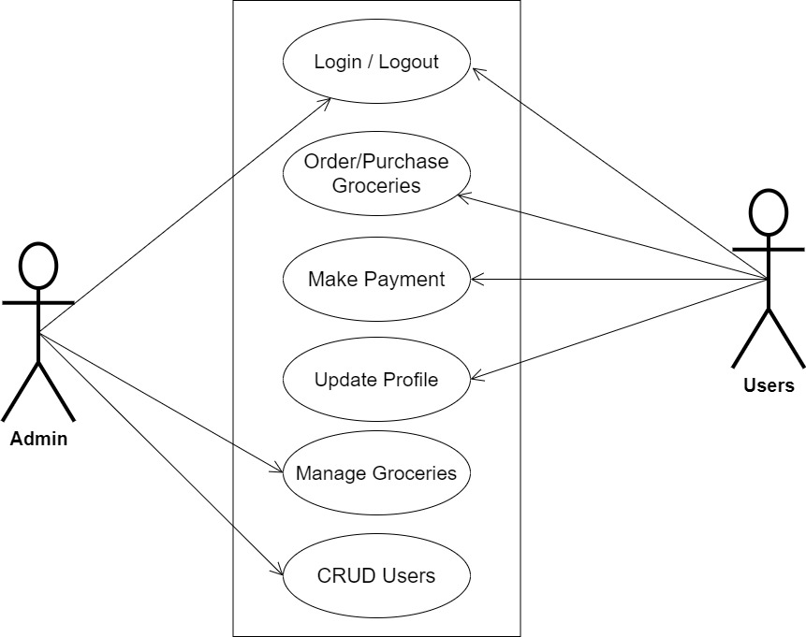

**Fig 3.1 System Use Case Diagram**

**3.3.2 Class Diagrams**

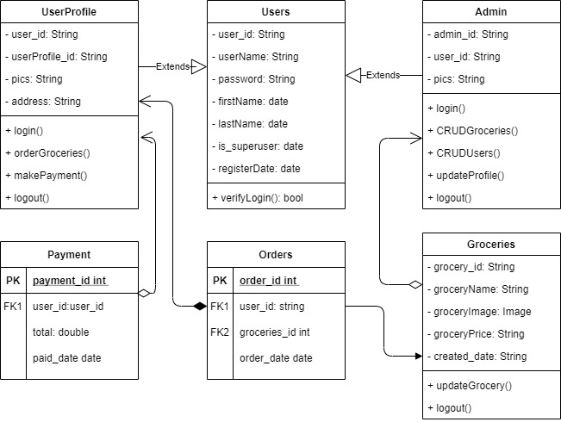

**Fig 3.2 System Class Diagram**

**3.3.3 Activity Diagrams**

**Login**

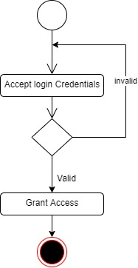The process for gaining access to the system is depicted in the diagram below; the username and password must be accurate to gain access.

**Fig 3.3 System Login Activity Diagram**

**Create Groceries**

The process for adding groceries to the system is depicted in the diagram below; The system ensures that the user is authenticated and authorized to perform the creation.

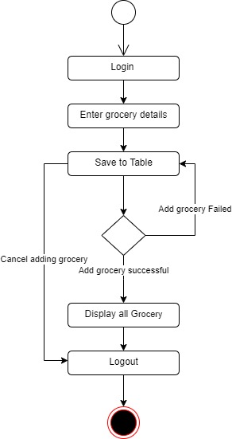

**Fig 3.4 Create Groceries Activity Diagram**

**Make Purchase**

The process for adding to the cart and making payment for the groceries is depicted in the diagram below; The system ensures that the user is authenticated and authorized to perform the purchase for validity purposes.

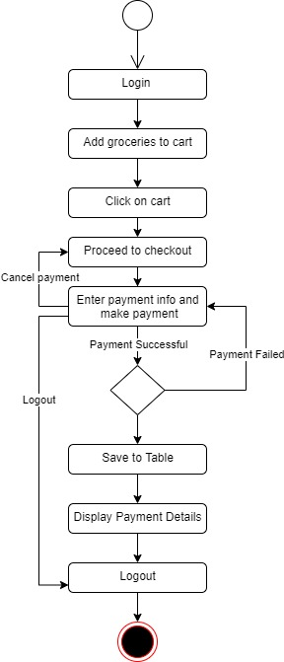

**Fig 3.5 Make Purchase Activity Diagram**

**3.4 Database Design**

The following are some of the input specifications used in this project work.

1. Users Table: contains the generic information of all system users.
2. Groceries Table: contains every grocery registered on the system.

**Table 3.1 Users Input Specification Table**

|  |  |  |  |  |  |
| --- | --- | --- | --- | --- | --- |
| **Field Name** | **Data Type** | **Null** | **Key** | **Length** | **Description** |
| user_id | Varchar | No | PK | 32 | Unique string for identifying users |
| username | Varchar | No |  | 20 | Unique name for users |
| password | Varchar | No |  | 128 | User Password |
| first_name | Varchar | No |  | 20 | User first name |
| last_name | Varchar | No |  | 20 | User last name |
| phone | Varchar | No |  | 11 | User phone number |
| email | Varchar | No |  | 100 | User email address |

**Table 3.2 Groceries Input Specification Table**

|  |  |  |  |  |  |
| --- | --- | --- | --- | --- | --- |
| **Field Name** | **Data Type** | **Null** | **Key** | **Length** | **Description** |
| grocery_id | Varchar | No | PK | 32 | Unique string for identifying citizens |
| groceryName | BigInt | No |  | 10 | Grocery name |
| groceryImage | BigInt | No |  | 60 | Image to identify the grocery |
| groceryPrice | Varchar | No |  | 60 | Price of the grocery |
| created_date | Varchar | No |  | 60 | Date the grocery was registered |

**3.5 Output Design**

This declares and displays the outcome of the given input. This system's output is dependent on its input. The output specification is listed below.

**Table 3.3 Users** **output design table**

**e-COMMERCE GROCERY BUSINESS TO CUSTOMER APPLICATION**

**List of the System Registered Users**

|  |  |  |  |  |  |
| --- | --- | --- | --- | --- | --- |
| **User_id** | **Username** | **First_name** | **Last_name** | **Phone** | **Email** |
| XXXX | XXXX | XXXX | XXXX | XXXX | XXXX |
| XXXX | XXXX | XXXX | XXXX | XXXX | XXXX |
| XXXX | XXXX | XXXX | XXXX | XXXX | XXXX |
| XXXX | XXXX | XXXX | XXXX | XXXX | XXXX |

**Table 3.4 Groceries** **output design table**

**e-COMMERCE GROCERY BUSINESS TO CUSTOMER APPLICATION**

**List of the System Registered Groceries**

|  |  |  |  |  |
| --- | --- | --- | --- | --- |
| **Grocery_id** | **GroceryName** | **GroceryImage** | **GroceryPrice** | **Created_date** |
| XXXX | XXXX | XXXX | XXXX | XXXX |
| XXXX | XXXX | XXXX | XXXX | XXXX |
| XXXX | XXXX | XXXX | XXXX | XXXX |
| XXXX | XXXX | XXXX | XXXX | XXXX |

**3.6 Input & User Interface Design**

This is a graphic depiction of the system interface; it will be designed to be user-friendly, responsive, and visually beautiful. Furthermore, it will be appropriately safeguarded, thus authorization will be required to see certain levels of the information. To help with the designs, a mid-fidelity wireframing program called Draw.io is employed.

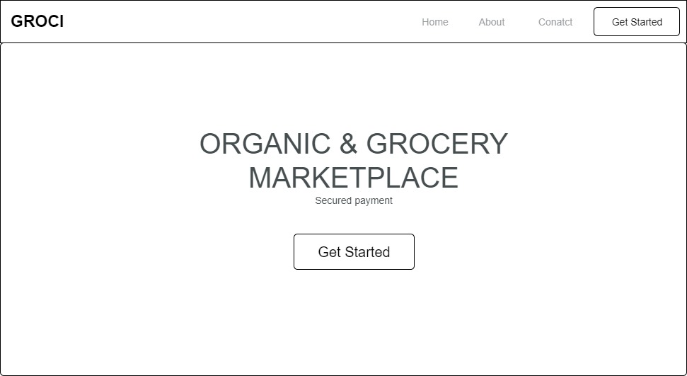

**Fig 3.6 Home Page**

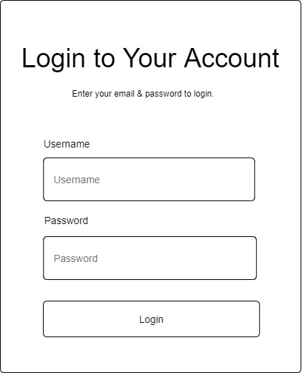

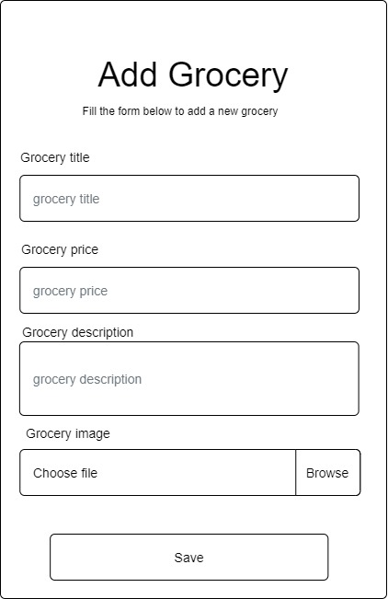**Fig 3.7 Login Form**

**Fig 3.8 Add Grocery**

**3.7 System Requirement**

Every software system built has a stated system requirement on which it is meant to execute for the best performance. The system requirements, on the other hand, are the bare minimum of hardware and software required for the system to work properly.

**3.7.1 Hardware Requirement**

System Hardware requirements include:

1. Minimum of 2 GB of RAM (Random Access Memory).
2. Minimum of Intel Dual core processor.
3. Minimum of 250GB HDD (Hard Disk Drive).

**3.7.2 Software Requirement**

The software requirements include:

1. At least Windows 7 OS (Operating System).
2. Vs. Code IDE installation.
3. Browsers include Chrome and Firefox.

**3.8 Choice of Programming Language**

This research project will be a web-based application built on a relational database architecture (SQLite). For frontend development, HTML (hypertext markup language), CSS (cascading style sheet), and JavaScript will be used, while Django (Python) will be used for backend programming. The combination of the above will help build a very robust eCommerce grocery business-to-customer application that will be useful, fast, and handy.

**REFERENCES**

Appelhans, BM, Lynch, EB, Martin, MA et al. (2021) Feasibility and acceptability of Internet

grocery service in an urban food desert, Chicago, 2011–2012. Prev Chronic Dis 10, E67.CrossRefGoogle Scholar

Khan, M. M., Shams-E-Mofiz, M., & Sharmin, Z. A. (2020). Development of E-Commerce-Based

Online Web Application for COVID-19 Pandemic. IBusiness, 12(04), 113–126. https://doi.org/10.4236/ib.2020.124008

Mohammed, M. K., Mahizebin, S., Zerin, A. S., (2020). “Development of E-Commerce-Based

Online Web Application for COVID-19 Pandemic” [*Department of Electrical and Computer Engineering, North South University, Dhaka, Bangladesh*](https://www.scirp.org/journal/articles.aspx?searchcode=Department+of+Electrical+and+Computer+Engineering%2c+North+South+University%2c+Dhaka%2c+Bangladesh&searchfield=affs&page=1&skid=0)*.*DOI: [10.4236/ib.2020.124008](https://doi.org/10.4236/ib.2020.124008). https://www.scirp.org/journal/paperinformation.aspx?paperid=104377

Mohammed, J. Y., (2021). “Smart Online Grocery Shopping App Development”.

<https://www.researchgate.net/publication/352761822_Smart_Online_Grocery_Shopping_App_Development>

Peregrin, T (2018) Understanding millennial grocery shoppers’ behavior and the role of the

registered dietitian nutritionist. J Acad Nutr Diet 115, 1380–1383.CrossRefGoogle ScholarPubMed

Zikra. A., Shital, M., Navindas. G., and Nidhi S., (2019). “Grocery store”. Bharati Vidyapeeth

College of Engineering Navi Mumbai, India. <https://www.ijtra.com/view/design-and-implementation-of-online-grocery-store.pdf>